Branch-Pipe
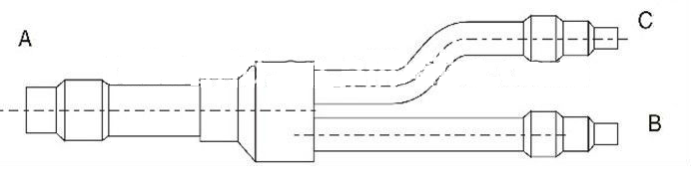
modelo | daikin modelo | de la tubería | longitud | a | b | c
Rw-khrp26mc-22t | Khrp26mc-22t | líquido | 334 | 12.7/15.9/19.1 | 15.9/12.7 | 15.9/12.7
 |  | de gas | 260 | 9.6 | 9.6/6.4 | 9.6/6.4
Rw-khrp26mc-33t | Khrp26mc-33t | líquido | 310 | 22.2/19.1 | 19.1/15.9 | 15.9/12.7
 |  | de gas | 270 | 12.7/9.6 | 9.6/6.4 | 9.6/6.4
Rw-khrp26mc-72t | Khrp26mc-72t | líquido | 430 | 31.8/28.6/25.4 | 25.4/19.1/15.9 | 19.1/15.9/12.7
 |  | de gas | 270 | 15.9/12.7 | 12.7/9.6 | 12.7/9.6/6.4

tipo |  | a | b | c
Utr-bp567l | tubería de gas | 35/41.2 | 19.1/22.3/25.4/28.6/35 | 28.6/35/41.2
 | tubo de líquido | 15.9/19.1 | 6.35/9.6/12.7/15.9 | 15.9/19.1

